# **Challenges in smart grid resiliency analyses**

The smart grid is a geographically distributed system consisting of multiple interacting and interdependent components that dynamically evolve with time.

* The challenge is to identify a framework and metrics for such a system to respond to such events, such as the response to an adversarial event, which is a complex task. The challenges that arise in such an endeavor are the temporal and spatial scale of the system, the one that immediately faces us is the challenge of such a large scale. It is a far more intricate task than would appear at first sight
* Secondly, the power grid is operated and maintained at different infrastructural and organizational scales ranging from an operating unit/facility to a nationwide service. The factors of importance at the national level, on the other hand, include greenhouse gas emissions and public inconveniences caused due to power interruptions. Developing a holistic framework that identifies different strategic options and proposes policies at all these levels involves the incorporation of a large number of factors, possibly including geopolitical ones, which have not been extensively addressed in the literature.
* Third, from a technical standpoint, several measures were developed and proposed to suffer from issues related to real-life implementation.
* For example, metrics such as storm average interruption frequency index (STAIFI) were shown to exhibit large variances when applied to the data of Hurricane Sandy.
* Large levels of uncertainty in the measures were identified as a challenge with the implementation of such indices towards quantifying the resilience of the grid.
* Fourth, metrics developed in the literature such as the estimated time of recovery have been identified as being difficult to estimate from the data, owing to the non-stationary nature of failure dynamics in the system.
* The above challenges are further accentuated with the introduction of a cyber-layer in the grid.

In addition to the above factors, it is also important for the metrics proposed in the literature to be tested and validated on reliable data obtained from the field. This would involve data from consumers, PMUs, distribution stations, and generating companies. However, such varied and rich datasets are presently not available in the literature, which also prevents large-scale industrial acceptance of the metrics developed in academia. It is therefore important to have standardized platforms that can be used to generate valid datasets for studies aimed at the resilience of the smart grid.

**Resilience of smart grids**

* **A Smart grid is geographically distributed system with continuous as well as discrete operating components**

**Properties such as vulnerability, self-healing and recovering ability, along with several others such as availability and logistics of components to be replaced, constitute the resilience of the smart grid**

**The below figure represents these properties and the factors influencing these components. Thus there is a need to analyze their interactions systematically.**

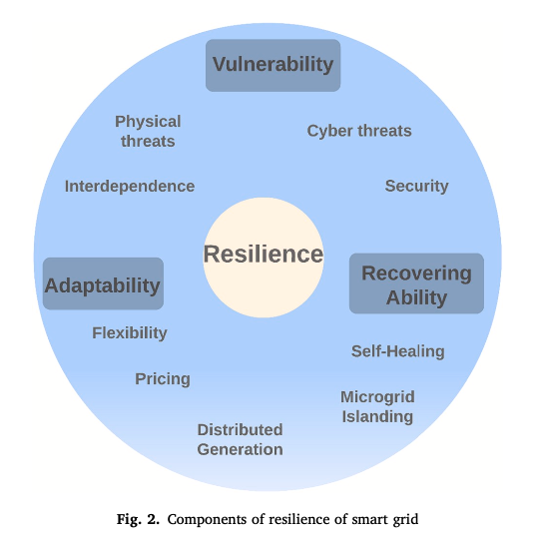

**Vulnerability : inability to withstand adverse events**

1. **rapid development and adoption of smart grid technologies such as dynamic pricing and microgrids increase the randomness in the grid’s operations and make it more prone to instabilities and failures**
2. **extreme environmental conditions also result in an inevitable disruption of ser- vices that the system is required to recover from in an agile and efficient manner.**
3. **introduction of a communication infrastructure on top of the physical grid , exposing the grid to cyber attacks**

**Flexibility / Adaptability : is a property that allows it to better react to adverse conditions.**

1. **appliance-specific scheduling [68] and microgrid islanding [69,70] result in better response of the grid to dynamically evolving scenarios.**

**This property can further contribute towards limiting the impact of the event and/or improve recovery time of the grid.**

**self healing / Recoverability: certain functionalities are automatically restored by a correction, or reconfiguration of the components**

**Ex: microgrid islanding : allowing independent operation of different regions till, say, a connecting line is replaced**

**The above factors are qualitatively and quantitatively studied for various applications like these**

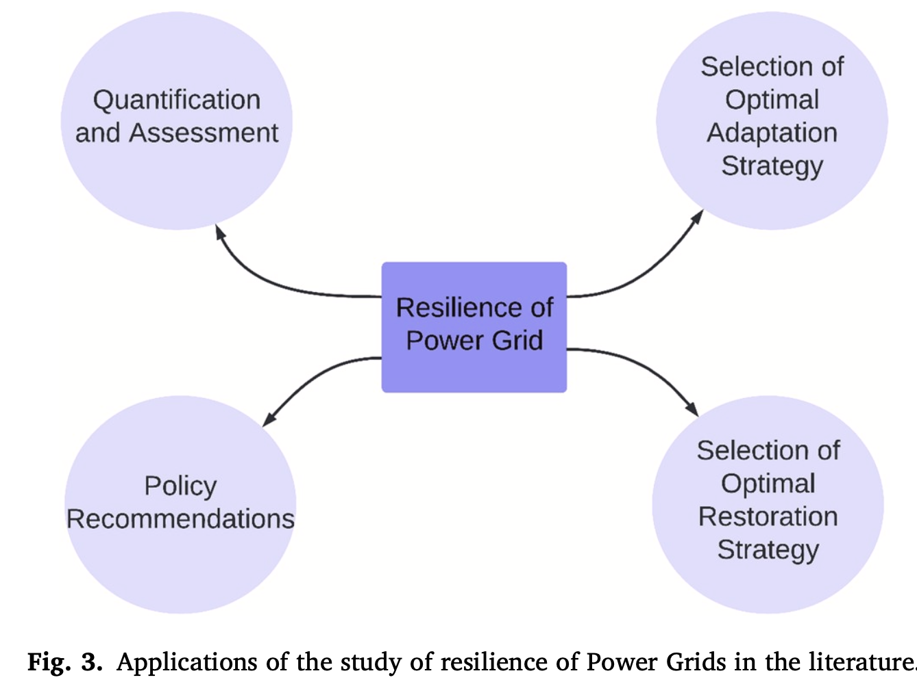

**and let us look at how that is done.**

1. **Qualitative**
2. **Quantitative**